PERCENTAGE CHANGE
Pearson Edexcel - Tuesday 19 May 2020 - Paper 1 (Non-Calculator) Higher Tier
1.
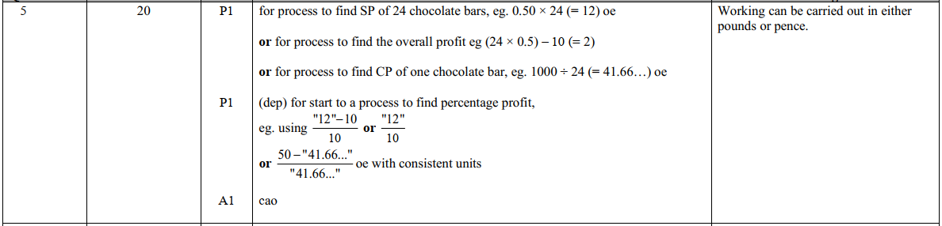
Pearson Edexcel - Tuesday 19 May 2020 - Paper 1 (Non-Calculator) Higher Tier
2.
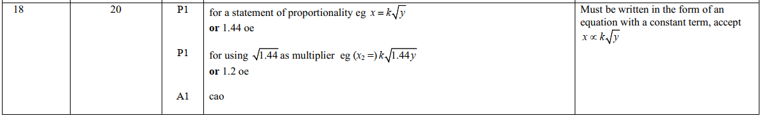
Pearson Edexcel - Monday 12 November 2018 - Paper 3 (Calculator) Higher Tier
3.
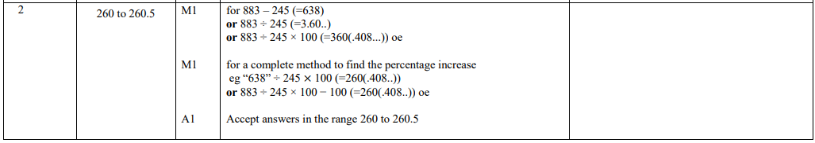
Pearson Edexcel - Tuesday 12 June 2018 - Paper 3 (Calculator) Higher Tier
4.
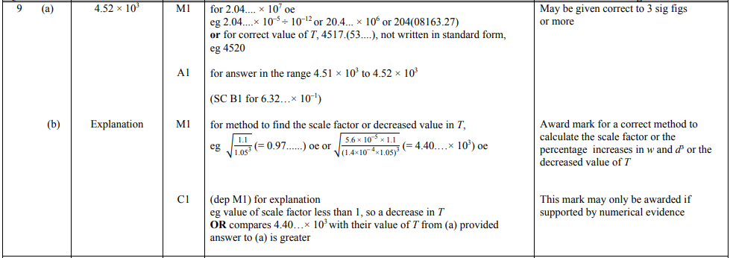
Pearson Edexcel - Monday 6 November 2017 - Paper 2 (Calculator) Higher Tier
5.
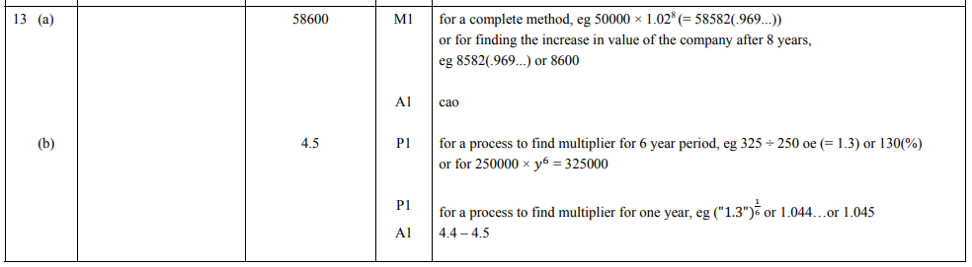
Pearson Edexcel - Specimen Papers Set 1 - Paper 2 (Calculator) Higher Tier
6.
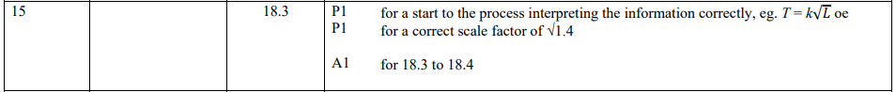
Pearson Edexcel - Sample Paper 1 - (Non-Calculator) Higher Tier
7.
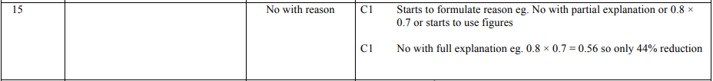
Pearson Edexcel - Friday 6 November 2015 - Paper 2 (Calculator) Higher Tier
8.
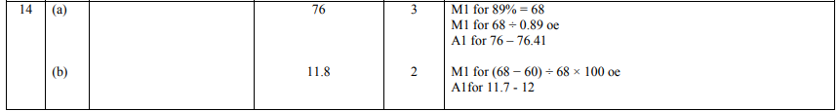
Pearson Edexcel - Thursday 8 November 2012 - Paper 2 (Calculator) Higher Tier
9.
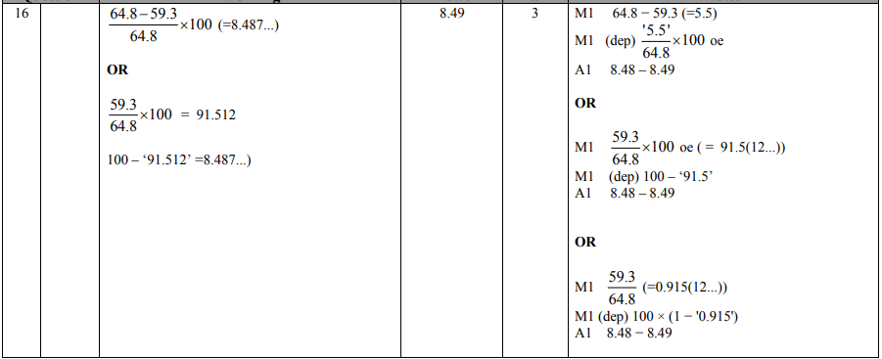
OCR GSCE – Thursday 5 November 2020 – Paper 5 (Non-Calculator) Higher Tier
10.
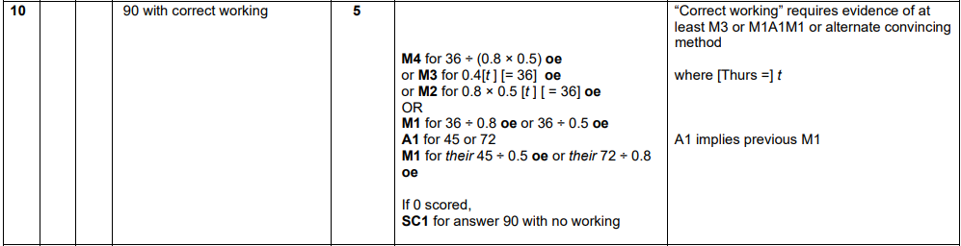
OCR GSCE – Thursday 7 November 2019 – Paper 5 (Non-Calculator) Higher Tier
11.

OCR GSCE – Tuesday 11 June 2019 – Paper 6 (Calculator) Higher Tier
12.
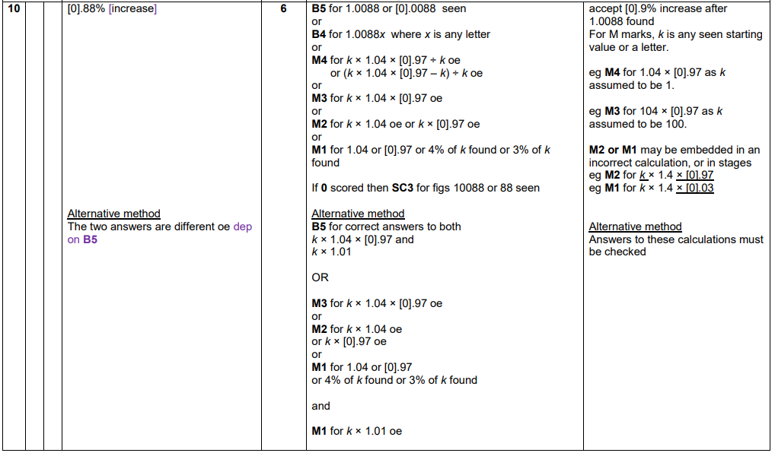
OCR GSCE – Thursday 8 November 2018 – Paper 5 (Non-Calculator) Higher Tier
13.
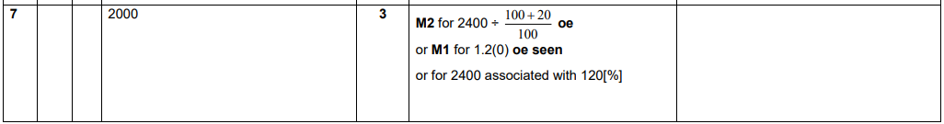
OCR GSCE – Thursday 8 November 2018 – Paper 5 (Non-Calculator) Higher Tier
14.
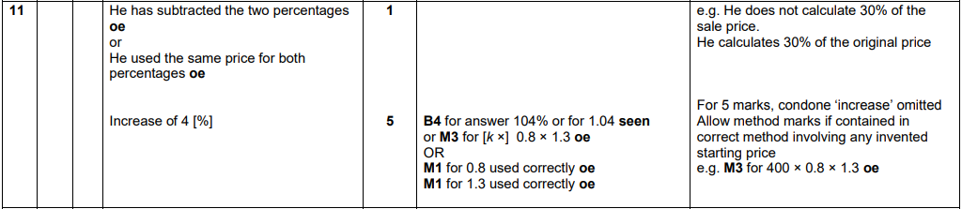

OCR GSCE – Thursday 7 June 2018 – Paper 5 (Non - Calculator) Higher Tier
15.
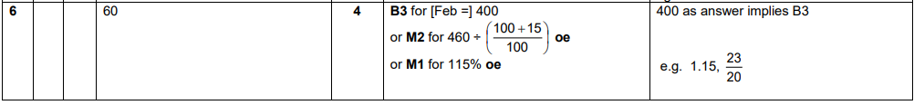
OCR GSCE – Sample Papers – Paper 4 (Calculator) Higher Tier
16.
AQA GSCE – Thursday 4 June 2020 – Paper 2 (Calculator) Higher Tier
17.
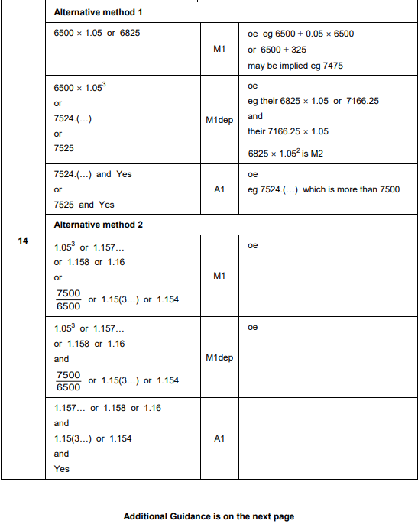
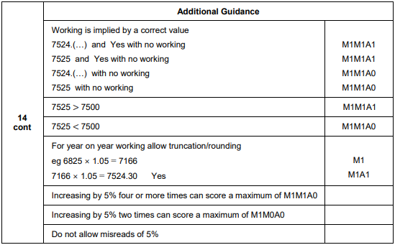
AQA GSCE – Tuesday 6 November 2018 – Paper 1 (Non - Calculator) Higher Tier
18.
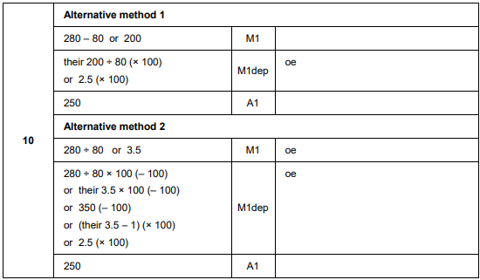

AQA GSCE – Monday 12 November 2018 – Paper 3 (Calculator) Higher Tier
19.
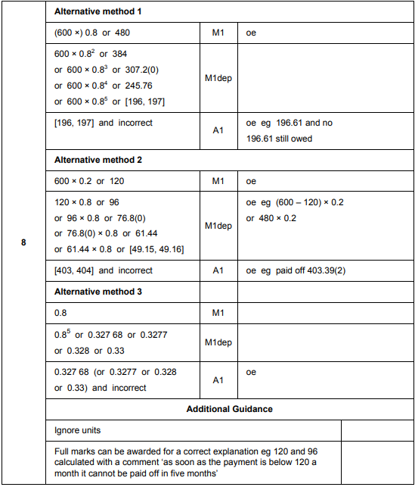

AQA GSCE – Tuesday 12 June 2018 – Paper 3 (Calculator) Higher Tier
20.
